**Starting the PiLock Program**

Once Rasberry Pi is powered up

Click Ctrl + Alt + t (Open terminal)

Click Alt + F11 (Fullscreen)

Type “cd PiLock” (change active directory to PiLock)

Type “python3 Main” (have Python3 run the Main program)

**Running the PiLock Program**

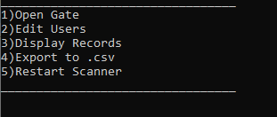

## 1)Opening the gate

On Main Menu

Type 1

Scan badge

<open gate> (While gate is open the screen will display who is in the cage and when they entered)

<go in and get parts>

<close gate>

## 2)Editing Users

On Main Menu

Type 2



Type 1 if your badge has been added with the Admin permissions

Type 2 if you need to log in as the default admin to add a badge

Scan Badge or Type Admin Account

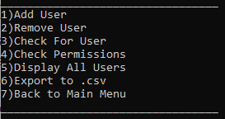

2.1)Add User

Type 1

Enter Full Name

Enter Login

Scan Badge

Enter permissions (1: Admin, 2:User W/ Gate Access, 3:User W/O Gate Access)

Verify Data

2.2)Remove User

Type 2

Scan Badge

2.3)Check For User

Type 3

Scan Badge

2.4)Check Permissions

Type 4

Scan Badge

2.5)Display All Users

Type 5

2.6) Export to .CSV

Type 6

2.7) Back to Main Menu

Type 7

## 3)Display Records

On Main Menu

Type 4

## 4)Export to .CSV

On Main Menu

Type 4

## 5)Restart Scanner

On Main Menu

Type 5